Guesstimate Framework

What is a Guess Estimate?

A guess estimate is an informed guess where there is enough information to **eliminate** the need of a **wild guess** but not enough information to make a **statistically sound estimate.**

A guesstimate is an estimate more greatly shaped by guesswork than an ordinary estimate would be (because many estimates can be made in a more scientific manner).

Numbers are thrown at us all the time.

* They are frequently used to scare us:
  + “Shark attacks doubled this year!”
  + “Dozens of lives could be saved by using infant car seats on airplanes!”
* They are needed to understand the world around us:
  + “The average American produces 100 cubic feet of garbage every year!”
  + “Nuclear power plants produce tons of high-level radioactive waste!”

You can make sense of these often confusing and sometimes contradictory numbers with just two tools:

1. An understanding of the meaning of large numbers.
2. An ability to make rough, common-sense, estimates starting from just a few basic facts.

What are Guesstimates relevant to Interviews?

* Interview questions based on guesstimates ask the candidate to estimate a number based on very limited information (hence “guess”).
* Successfully answering these questions relies on a combination of mental math, logical thinking, problem-solving skills, and background knowledge.

Approach for Solving Guesstimates :

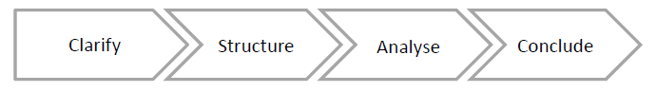

1. **Clarify the problem**

Guess estimate questions can sometimes be extremely vague and ambiguous. It is always advisable to clarify all your doubts about the question.

Let’s take an example :

You might be asked to find the number of flights that depart from Delhi. Now this question can have multiple interpretations.

* Is the interviewer concerned about passenger flights or cargo flights, or both?
* Is he talking about local flights or international flights?
* Is he only talking about IGI Airport or other airports in Delhi like Safdarjung, Hindon AF Station?

1. **Breakdown the problem**

Break down the actual problem into subproblems if possible. Estimating parameters on a segment level is far more accurate than making guesses on the overall.

Let's continue on the same example of the departing flights. Break it down into

* Local flights / international flights / layover flights
* Passenger flights / cargo flights
* Peak hours / normal hours / non operational hours
* Weekdays and Weekends

1. **Make assumptions**

* There are various approaches to solve guesstimates, but robust assumptions should back each of them.
* Problems like market sizing are based on many assumptions, and a wrong one can lead to a huge negative impact.

**For example, finding the number of toothbrushes sold in India in a year is heavily dependent on the average life of a toothbrush. Assuming it to be six months instead of four can completely change your solution.**

* So it is always advised to take buy-in from the interviewer while assuming any number but be prepared to defend your assumptions with logic and rationale.

Apply your general awareness of the environment you’re dealing with to come up with numbers.

The golden rule is to use beautiful numbers.

* Sure, you may get the exact population of Delhi as 18,686,902 with a simple Google search but it sure doesn’t sound as pretty as 20,000,000.
* How many people to assign to different age groups? Work in percentages.
* We’re a young country, so the maximum weightage goes to the 15–40 year group.

1. **Consolidate the pieces**

* Use calculations to consolidate the pieces into a final answer.
* Add all the assumptions and numbers that you have come up with.
* If you have sub problems you can adjust the numbers and check if additional cases are to be checked.
* It is always a good idea to keep on validating intermediate numbers using your experience and sense checks.
* At this point you can check or think about any edge case or any additional scenario related to the problem and account for it.

Additional points :

* There’s no correct answer or correct approach to a guesstimate question.
* Make defendable, fact-based estimations. Reasons for your assumptions are important.
* When answering a guesstimate, you want to showcase your ability to analyze a situation and form conclusions by thinking out loud. You’ll drive toward a conclusion through a series of increasingly specific analyses.
* Always take buy-in from the interviewer for your assumptions, avoiding asking questions leading to the direct answer.
* Round up the numbers for easy calculations. Answer in terms of ranges instead of absolute figures.

**Game 24/7 - Guesstimate**

1. Problem Statement
2. Learning Objective
3. Prerequisites
4. References
5. Approach
6. Thought Process
7. Logic Building
   1. Thumb Rules
   2. Newly Launched Game
      1. Assumptions
      2. Calculations
   3. Already Established Game
      1. Assumptions
      2. Calculations
8. **Problem Statement**

**Games 24/7** had launched an arena based first person shooting game back in the year 2020. The game became very popular among the users in a very short span of time. Now the company intends to launch a similar game where they’re introducing a brand new map and some other cool features as well.

You, as a **Product Analyst** hired by Games 24/7, have to prepare a pricing strategy for them, where the Winner gets prize money Rs. 1 lakh and the Runner up gets Rs. 50k for each gaming event.

**What should be the per game entry price for a single participant?**

1. **Learning Objectives**

The sole purpose of this guesstimate is to check -

* How structured is your approach?
* How comfortable are you with estimating numbers?
* Can you do back of the mind calculations and validate the numbers?

1. **Prerequisites**

Things that we need to know before starting with the estimation -

* Market share of the game.
* Region where we’re calculating the estimate.

1. **References**

* We will take reference from the existing game tournaments that are already happening in India.
* This year the overall pool prize for the BGMI tournament was around 1.5 Crs.
* CoD also has a similar prize pool of taking into account all the contests for the day.
* Comparing this with our problem statement shows that the price money is fairly low as compared to BGMI & CoD.

1. **Approach**

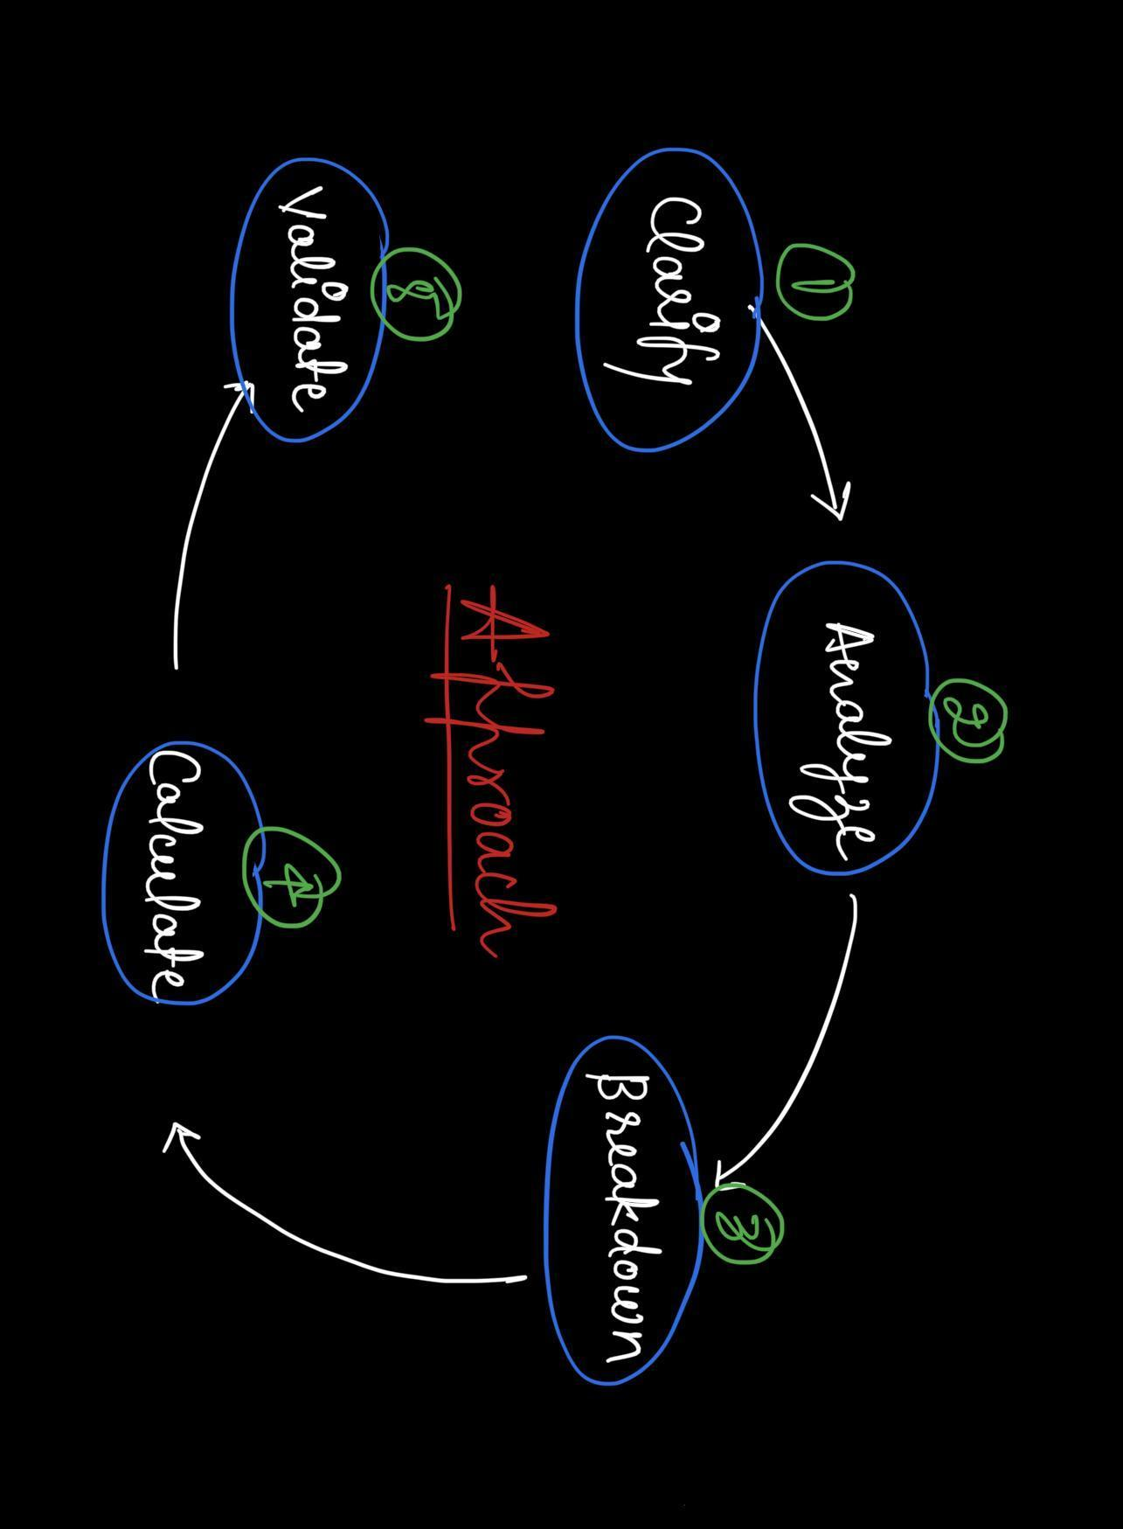

1. **Clarify** **-** First try to understand the problem statement and gather all the information required for the estimation.
2. **Analyze -** Analyze what all information you currently have and how you can use it to solve the problem in hand.
3. **Breakdown -** Decide a criteria and break things down into several categories. Smaller units are generally easier to deal with.
4. **Calculate -** Note down the assumptions and use them as thumb rules to make calculations. The numbers don’t need to be exact. Just specify a range or an approximation.
5. **Validate -** Finally, validate your results in terms of the business metric. Make sure that everything makes sense.
6. **Thought Process**
7. We can keep two separate gaming modes for free & cash players.
8. We can offer special upgrades (paid) to the players.
9. We can also earn by hosting advertisements on our platform.
10. We can allocate a separate budget for self promotion.
11. We’ll have to create a special team for application maintenance.
12. Hosting the server online will have a separate cost.
13. **Logic Building**

The idea is to classify the game into 2 different categories, one that has a larger market share and the other one which was launched recently and is relatively new in the gaming industry.

1. **Newly launched game**
2. **Already established game**

**7.1 Thumb Rules**

* We are considering the gaming event to be launched in India.
* The game is meant only for individual participants. Team entries are not allowed.

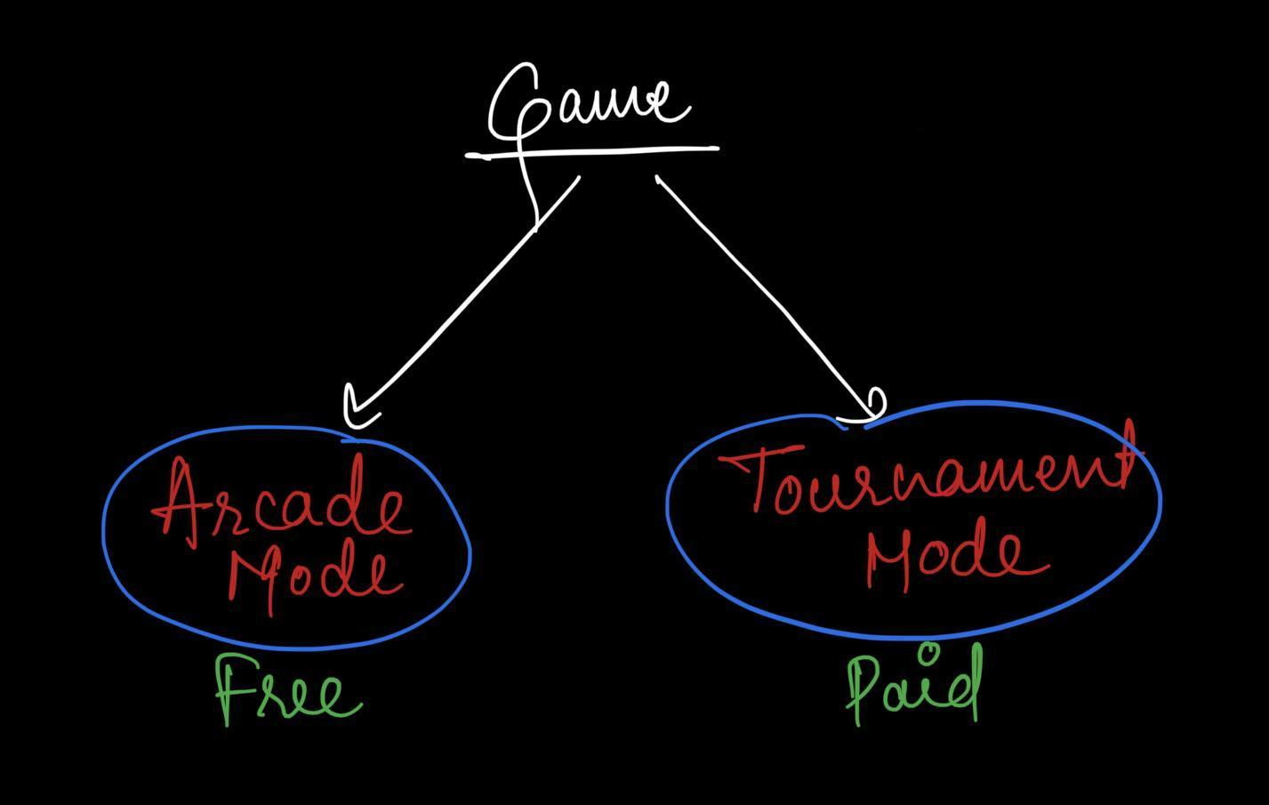

* The game will have two different gaming modes.

1. **Arcade** **mode** -
   1. This will be a practice lobby without any entry fee.
   2. No prizes will be given to the winners.
   3. The players can use this gaming mode to upskill themselves and increase their rank.
2. **Tournament mode** -
   1. This will be an open challenge for players around the company to compete against each other.
   2. Participants will have to pay an entry fee to join the tournament.

* **Royalty Cards** -
  + These upgrades will be offered to both free as well as cash players.
  + The special upgrades are only aesthetics like weapon skin, custom outfit, etc.
  + They do not give any advantage to the user.

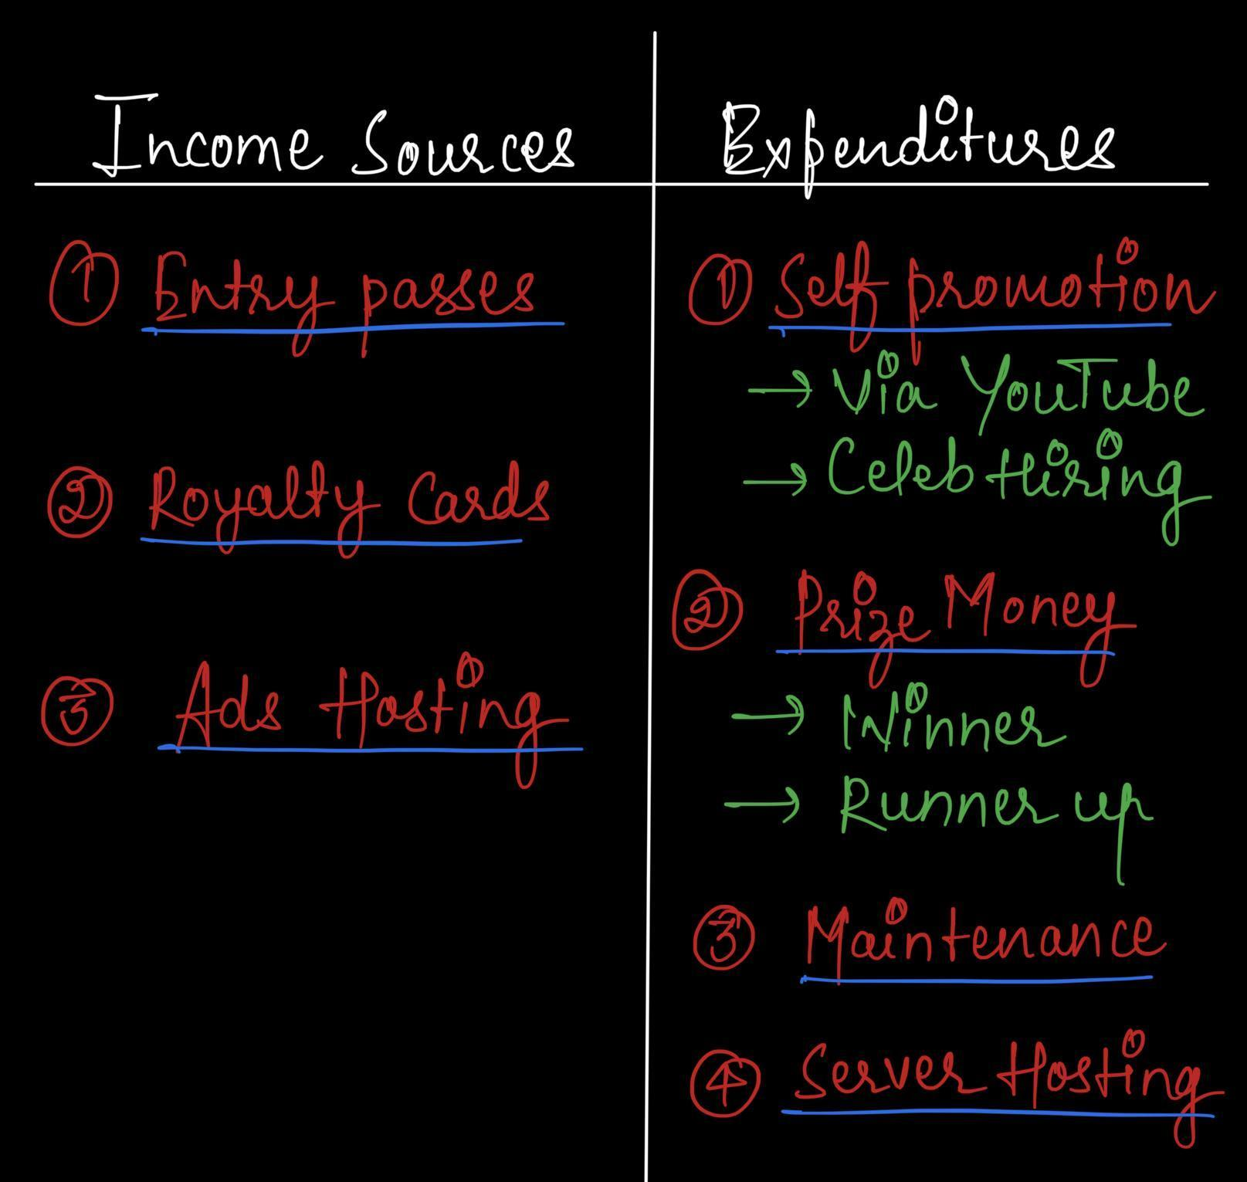

**7.2 Newly Launched Game -**

**7.2.1 Assumptions *(Parameters provided by the company)***

In order to proceed with our estimation, we first need to make some basic assumptions that’ll help us stick to a specific problem.

1. Since the market share of this game is relatively small, the number of **active users** on the platform will be **5k**.
2. 80% of the total active users will be free players. Only the rest **20% players** will participate in the **paid tournament.**
3. **15%** of the **combined total users** have purchased Royalty Cards that generate around **2.5k in revenue per user**.
4. The other 85% users haven’t purchased any upgrades.
5. No. of contests per day - **Daily 5 arcade games and 1 tournament** will be organized to engage more and more players.
6. **No advertisement** will be shown to the **tournament players**.
7. A **30 seconds ad** will be shown to the free players whenever they first open the game (**every day**) in **arcade mode**.
8. **Pricing** for the associated companies **to host a 30 seconds ad** on the platform will be **1 lakh**.
9. The company is planning to allocate a total amount of **4.5 lakhs/month for advertising** their game via YouTube, spending around **15k per day**.
10. To promote the product they might have to **hire celebrities** as well. So let’s say **5 lakhs (one time)** will be spent for such promotions.
11. **Maintenance cost** for the gaming application will be something around **3 lakhs/month** due to less no. of players.
12. To run the servers, cost will be relatively low in the beginning but since we have to **host servers** for both free & cash players let’s keep it around **5 lakhs/month**.

**7.2.2 Calculations**

1. **Incoming Cash Flow**

* Total no. of active users = *5k* *(from pt. i)*
* No. of paid users = *20% of 5k = 1k* *(from pt. ii)*
* Let the entry price for each game in Tournament mode be x
* Total amount received from users = No. of paid users * No. of tournaments * Entry price per game * No. of days = *1k * 1 * x * 30 = 30k * x*
* Revenue generated from Royalty Card purchasers = *15% of 5k = (0.15 * 5,000) * 2,500 = 18.75 lakhs (from pt. iii)*
* Revenue generated from ad hosting = No. of ads * No. of days * Cost price for each ad = *1 * 30 * 1 lakh = 30 lakhs* *(from pt. vii , viii)*
* **Total income generated** = Income from entry price + Revenue from Royalty Cards + Revenue from ad hosting = *30k * x + 18.75 lakhs + 30 lakhs = 1000 x + 48.75 lakhs*

1. **Outgoing Cash Flow**

* Total prize money for a game = prize money for winner + prize money for runner up = *1+0.5 = 1.5 lakhs*
* Total prize money for a month with 1 contest per day = *30 * 1 * 1.5 = 45 lakhs*
* Budget for promotions = No. of days * Expenditure per day + Celeb fee = *30 * 15k + 5 lakhs = 9.5 lakhs (from pt. ix, x)*
* **Total expenditure** = Maintenance + Server Hosting + Promotions + Prize money = *3+5+9.5+45 = 62.5 lakhs* *(from pt. xi, xiii)*

1. **Equating the incoming & outgoing cash amount -**

30k * x + 48.75 lakhs = 62.5 lakhs

30k * x + = (62.5 - 48.75) lakhs

30k * x = 13.75 lakhs

x =13,75,000/30,000

x = 45 (approx.)

Therefore, the entry price for a single participant, for each game would be **Rs. 45/-**

**7.3 Already Established Game -**

**7.3.1 Assumptions *(Parameters provided by the company)***

In order to proceed with our estimation, we first need to make some basic assumptions that’ll help us stick to a specific problem.

1. Since the market share of this game is relatively large, the number of **active users** on the platform will be **25k**.
2. 75% of the total active users will be free players. Only the remaining **25% players** will participate in the **paid tournament**.
3. **10%** of the **combined total users** have purchased Royalty Cards that generate around **2.5k in revenue per user**.
4. The other 90% users haven’t purchased any upgrades.
5. No. of contests per day - **Daily 10 arcade games and 3 tournaments** will be organized to engage more and more players.
6. **No advertisement** will be shown to the **tournament players**.
7. A **20 seconds ad** will be shown to the free players whenever they first open the game (**every day**) in **arcade mode**.
8. **Pricing** for the associated companies **to host a 20 seconds ad** on the platform will be **1 lakhs**.
9. Since the game is already popular, the company spends a relatively small amount (**1.5 lakhs/month** or around **5k per day**) on advertisements.
10. **Maintenance cost** for the gaming application is high, something around **15 lakhs/month**.
11. To **run the servers**, cost will also be high (around **25 lakhs/month**).

**7.3.2 Calculations**

1. **Incoming Cash Flow**

* Total no. of active users = *25k (from pt. i)*
* No. of paid users = *25% of 25k = 6.25k* *(from pt. ii)*
* Let the entry for each game in Tournament mode be x
* Total amount received from users = No. of paid users * No. of tournaments * Entry price per game * No. of days = *6*.*25k * 3 * x * 30 = 562.5k * x*
* Revenue generated from Royalty Card purchasers = *10% of 25k = (0.10 * 25,000) * 2,500 = 62.5 lakhs* *(from pt. iii)*
* Revenue generated from ad hosting = No. of ads * No. of days * Cost price for each ad = *1 * 30 * 1 lakh = 30 lakhs* *(from pt. vii, viii)*
* **Total income generated** = Income from entry price + Revenue from Royalty Cards + Revenue from ad hosting = *562.5k * x + 62.5 lakhs + 30 lakhs = 562.5k * x + 92.5 lakhs*

1. **Outgoing Cash Flow**

* Total prize money for a game = prize money for winner + prize money for runner up = *1+0.5 = 1.5 lakhs*
* Total prize money for a month with 3 contests per day = *30 * 3 * 1.5 = 135 lakhs*
* Budget for promotions = No. of days * Expenditure per day = *30 * 5k = 1.5 lakhs (from pt. ix)*
* **Total expenditure** = Maintenance + Server Hosting + Promotions + Prize money = *15+25+1.5+135 = 176.5 lakhs (from pt. x, xi)*

1. **Equating the incoming & outgoing cash amount -**

*562.5*k * x + 92.5 lakhs = 176.5 lakhs

*562.5*k * x + = (176.5 - 92.5) lakhs

*562.5*k * x = 84 lakhs

x = 8,525,000/562,500

x = 15 (approx.)

Therefore, the entry price for a single participant, for each game would be **Rs. 15/-**

**Guesstimates:**

**Q. How many iPhones users are there in India at present?**

1. Suppose, we are considering all models of the iPhone.
2. Total population = 1 Billion
3. Does every age group use an iPhone?
   1. Usually kids and senior citizens don’t use iPhone. (40%)
   2. So total eligible population = 60% (600 Million)
4. Can the entire eligible population afford an iPhone?
   1. Usually only upper class and upper-middle class people can afford an iPhone.
   2. So lets say roughly 70% of the eligible population can afford an iPhone. (70% of 600M = 420M)
5. Among the total eligible population who can afford an iPhone, how many actually use it?
   1. For this, we need to understand the market-share of the iPhone in India.
   2. Let's say it's roughly 8%.
   3. So total users = 8% of 420M = 33.6M

Discussion points that can be thought of during interviews:

* **Market Share Range:** Market share estimates can vary, so it's valuable to consider a range. Instead of a fixed 2%, you can estimate a range, e.g., 1.5% to 2.5%. This acknowledges the uncertainty in market share data.
* **Affordability:** iPhones come in various price ranges. Consider the distribution of affordable models like the iPhone SE and more expensive models. A different market share might apply to different price segments.
* **Urban vs. Rural Split:** Urban areas often have higher iPhone adoption rates. Guesstimating market share for urban and rural areas separately may provide a more accurate overall estimate.
* **Competing Brands:** The presence of strong competitors like Android-based smartphones can impact Apple's market share. Look at data on Android market share and its impact on Apple's share.
* **User Demographics:** Guesstimates can be refined by considering demographic factors like income, age, and occupation. A more detailed analysis can provide a nuanced view of iPhone adoption among different groups.
* **Online vs. Offline Sales:** Consider the balance between online and offline sales channels. Apple's market share may vary based on where users purchase their devices.
* **Government Policies:** Changes in import duties or government policies on electronics can influence market share.
* **Market Research Reports:** Search for and analyze market research reports for up-to-date market share data and trends. Combining various sources can provide a more comprehensive picture.

Incorporating these additional discussion points into your guesstimate can help you refine the estimate and account for various factors that may influence the number of iPhone users in India.

**Q. How many refrigerators are sold in India every year?**

1. **Market Share and Sales Data:** Find market research reports or industry data that provide an estimate of the market share for major refrigerator manufacturers (e.g., Samsung, LG, Whirlpool) in India. Look for annual sales figures or growth rates within the industry.
2. **Total Household Number:** Estimate the total number of households in India. According to government data or reliable estimates, India had around 248 million households as of my last knowledge update in 2022.
3. **Average Replacement Period:** Consider the average replacement or upgrade period for refrigerators. The typical lifespan of a refrigerator can be around 10-15 years. This means that on average, a household might replace their refrigerator once every 10-15 years.
4. **Apply Market Share:** Using the market share data obtained in step 1, apply it to the total number of households in step 2 to estimate the number of refrigerators sold by each manufacturer. Then, sum up the estimates to get a rough total number of refrigerators sold in India.  
   Example:
   1. Estimated market share of a leading refrigerator manufacturer in India: 30%
   2. Total number of households in India: 248 million
   3. Average replacement period: 12 years
   4. Estimated refrigerators sold annually by that manufacturer: (30% of 248 million) / 12 = 6.2 million refrigerators sold per year for that manufacturer.
5. **Repeat for Major Manufacturers:** Repeat the calculation for other major refrigerator manufacturers, and then sum up the estimates for each to arrive at a rough total number of refrigerators sold in India annually.
6. **Variability and Considerations:** Keep in mind that this is a very rough estimate and doesn't account for variations in market share, regional preferences, different refrigerator types (e.g., single-door, double-door), or government initiatives that may impact sales. Additionally, economic conditions and technological advancements can influence replacement rates.
7. **Data Sources:** Try to find and utilize the most recent and reliable data sources, such as government statistics, industry associations, and market research reports, to improve the accuracy of your guesstimate.